PROJECT REPORT
ON
eBlood Care: Easy access for patients and donors
Submitted in partial fulfilment of Bachelor of Computer Applications (BCA)
To
UTTARANCHAL UNIVERSITY, DEHRADUN

UTTARANCHAL SCHOOL OF COMPUTING SCIENCES
SESSION (2025-26)

Submitted To: Submitted by:
Under the Supervision of Janvi Sharma
Ms. Divya Rawat Enroll. No. UU2509000159
(Assistant Professor) BCA 2 sem.
USCS Section – D

ACKNOWLEDGEMENT
The most awaited moment of any endeavor is successful completion, but nothing can be done successfully if done alone. I would like to express my sincere gratitude to everyone who contributed to the successful completion of this mini project.
Firstly, and foremost, I would like to thank Prof. (Dr.) Sonal Sharma, Director USCS for providing a healthy and encouraging environment to study.
I profusely thankful to the Head of Department, USCS, Prof. (Dr.) Sameer Dev Sharma,USCS and my Project Mentor Ms. Divya Rawat, Assistant Professor. She has been generous enough to provide me an opportunity and accepting my candidature for the most valuable guidance and affordable treatment given to us at every stage to boost my morale.

Janvi Sharma
Enroll. No. UU2509000159
BCA 2nd sem.

DECLARATION
I hereby declare that the synopsis report entitled eBlood Care by Monika Holaria to Uttaranchal School of Computing Sciences, Uttaranchal University. The project was done under the guidance of Ms. Divya Rawat. I further declare that the work reported in this project has not been submitted and will not be submitted, either in part or in full, for the award of any other degree or diploma in this university or any other university or institute.

Janvi Sharma
Enroll no. UU2509000159
BCA 2nd sem.

CERTIFICATE OF ORIGINALITY
This is to certify that Janvi Sharma student of BCA 2nd Semester of Uttaranchal School of Computing Sciences, Uttaranchal University, Dehradun, has completed the Synopsis Report on “eBlood care” in C Language for the Batch (2025-2028).

Under the Guidance of
Ms. Divya Rawat
Assistant Professor
USCS
Uttaranchal University

Contents
ACKNOWLEDGEMENT 2
DECLARATION 3
CERTIFICATE OF ORIGINALITY 4
INTRODUCTION 6
OBJECTIVE 7
SCOPE OF THE PROJECT: 8
SYSTEM ANALYSIS / REQUIREMENTS: 9
FEASIBILITY STUDY 11
SOFTWARE REQUIREMENTS 13
FLOWCHART 14
DATA FLOW DIAGRAM 15
PERRT CHART 17
GANTT CHART 18
CODE 19
TESTING 24
BIBLOGRAPHY 25

INTRODUCTION
In today’s world, timely availability of blood can save many lives. During accidents, surgeries, childbirth, or serious illnesses, patients often require blood urgently. However, finding the right blood group at the right time is still a major problem. Many families struggle to contact blood banks, hospitals, or donors during emergencies. Approximately 12,000 people die daily due to non-availability of blood, often caused by inadequate storage, poor distribution and in some cases a lack of blood banks in districts.
To solve this problem, we are developing eBlood Care, a digital application that connects patients, blood donors, and hospitals on a single platform. The main aim of this project is to provide quick and easy access to blood in emergency situations.
The eBlood Care application will allow patients to search for available blood groups in nearby hospitals and blood banks. Registered donors can receive notifications when someone needs blood. Hospitals can update their blood stock and manage requests efficiently through the system.
This project uses modern technology such as mobile applications, real-time data updates, and location-based services to reduce delays and improve communication between patients, donors, and hospitals.
The main goal of eBlood Care is to save lives by making blood availability faster, more transparent and more organized. It also promotes voluntary blood donation and helps build a strong community support system.
Key Features of the Application
User Registration & Login
- Separate registration for Patients, Donors, and Hospitals
- Secure login using mobile number & OTP
- Profile management (blood group, location, contact data

Real-Time Blood Availability
- Check available blood groups in nearby hospitals
- Livestock updates
- Filter by blood group and location
Emergency Blood Request
- Patients can post urgent blood requests
- Nearby donors receive instant notifications
- Quick response system for emergencies
Location-Based Search
- Shows nearest blood banks and hospitals
- Contact details

OBJECTIVE

- To Provide Fast Access to Blood in Emergency Situations
The primary objective of this project is to help patients quickly find the required blood group during emergencies. The application will reduce the time spent searching for blood by providing instant information about available donors and nearby hospitals.
- To Create a Common Platform for Donors, Patients, and Hospitals
This project aims to develop a single digital platform that connects blood donors, patients, and hospitals. It will improve communication and coordination among them, making the process of blood donation and blood requests more organized and efficient.

SCOPE OF THE PROJECT:

- Quick Blood Search: The system will help patients quickly find the required blood group from nearby hospitals and registered donors during emergency situations.
- Connection between Donors, Patients and hospitals: The application will provide a common platform where donors, patients, and hospitals can communicate and coordinate easily.
- Real Time Blood Availability: Hospitals can update their blood stock so users can check the availability of different blood groups in real time.
- Emergency Blood Request: Patients can send urgent blood request through the application to nearby donors and hospitals
- Donor Registration System: people can register as blood donors and receive notifications when someone needs blood.
- Improved Blood Management: The system will help hospitals maintain proper digital records of blood donations and blood requests.

SYSTEM ANALYSIS / REQUIREMENTS:

The eBlood Care system is designed to solve this problem by creating a digital platform that connects patients, blood donors, and hospitals. Through this system, users can quickly check blood availability, send emergency requests, and communicate with donors or hospitals. This will make the process of finding blood faster, easier, and more organized.
Problem Definition:
- Patients often face problems in finding the required blood group quickly during accidents, surgeries, or serious medical conditions.
- Many hospitals and blood banks do not provide updated information about available blood stock.
- People usually have to contact multiple hospitals, blood banks, or personal networks, which wastes valuable time.
- There is no common platform where patients can directly connect with available blood donors.
Proposed Solution:
- Create an application that connects patients, blood donors, and hospitals on one platform for easy communication.
- Allow hospitals to update their blood stock so users can check available blood groups instantly.
- Provide an option for patients to send urgent blood requests to nearby donors and hospitals.
- Enable people to register as blood donors and store their blood group and contact details in the system.
- Help patients find nearby hospitals and blood banks that have the required blood group.
System Components:
1. User Interface (Frontend)
- The visible part of the application that users see and use.
- Responsible for designing pages like login page, registration page, and blood search page.
- Collects user input and sends it to the backend.
- Ensures smooth navigation and better user experience.
2. Backend System
- The main processing part of the system.
- Handles data storage, data processing, and system logic.
- Manages user accounts, blood requests, and donor information.
- Connects the frontend with the database to retrieve and store data.

Functional Requirements
- User Registration and Login
The system should allow patients, donors, and hospitals to register and log in to the application.
- Blood Search
Patients should be able to search for the required blood group.
- Blood Request
Patients should be able to send a blood request during emergencies.
- Donor Registration
Donors should be able to register their details such as name, blood group, and contact number.
- Blood Stock Update
Hospitals should be able to update and manage their blood availability in the system.
- Notification System
The system should notify donors when blood is required.
- Data Storage
The system should store information about donors, patients, and blood requests.

Non-Functional Requirements
    - Security
The system should protect user data and provide secure access.
    - Performance
The application should work fast and respond quickly to user requests.
    - Reliability
The system should run smoothly without frequent errors or crashes.
    - User-Friendly Interface
The application should be simple and easy for users to understand and use.
    - Availability
The system should be available anytime so users can access it during emergencies.

FEASIBILITY STUDY
A feasibility study is conducted to assess the practicality and viability of a project before its development. In the case of a eBlood Care, the goal is to determine if it is technically, financially, and operationally feasible. This study typically includes an analysis of four key areas: technical feasibility, economic feasibility, operational feasibility, and legal feasibility. Below is a detailed feasibility analysis for a Parking Management System.
- Technical Feasibility:
• Availability of Technology
The eBlood Care project can be developed using the C programming language, which is simple and widely used for programming. The required technology is easily available and does not require complex tools.
• Hardware Availability
The system can be developed and executed using basic hardware such as a computer or laptop, keyboard, and mouse. These devices are commonly available in college computer labs.
• Software Availability
The project requires a C compiler (such as Turbo C or GCC) to write, compile, and run the program. These software tools are free and easily accessible.
• Integration with Existing Systems
The system can be integrated with existing hospital or blood bank systems to manage blood records more efficiently.
• System Reliability
The system is designed to work smoothly and provide accurate information about blood availability. With proper programming and testing, the system can perform its functions without major technical problems.

Economic Feasibility

Low Development Cost
The eBlood Care project can be developed using basic resources such as a computer, internet connection, and the C programming language. These resources are easily available in college labs, so the development cost is very low.

No Expensive Software Required
The project uses simple programming tools and compilers that are free or already available. Therefore, there is no need to purchase expensive software.
- Minimum Hardware Requirement
Only a basic computer or laptop is required to develop and run the system, which reduces the overall cost of the project.
- Time Efficient Development
Since the system is simple and uses basic programming concepts, it can be developed within a short period of time, saving both time and resources.
- High Benefit Compared to Cost
Even though the cost of development is low, the system can provide high benefits by helping patients find blood quickly and improving communication between donors, patients, and hospitals.

Operational Feasibility

Easy to Use System

The eBlood Care application is designed with a simple and user-friendly interface so that patients, donors, and hospital staff can easily understand and operate it. Even users with basic computer knowledge can use the system without much difficulty.

• Improves Emergency Response
In emergency situations, patients often struggle to find the required blood group quickly. This system helps reduce the time needed to search for blood by providing quick access to donor and hospital information.

• Better Communication and Coordination
The system connects patients, blood donors, and hospitals on one platform. This improves communication and makes the process of requesting and donating blood more organized.

• Efficient Blood Management
Hospitals can update and manage blood stock through the system. This helps maintain accurate records of available blood groups and reduces confusion or misinformation.

• Practical and Beneficial for Society

The system encourages voluntary blood donation and helps ensure that blood is available when needed. Because it is useful, simple, and helpful in saving lives, the system is operationally feasible.

Legal Feasibility

• Protection of User Data
The system must protect the personal information of users such as name, contact number, and blood group. User data should be stored securely and should not be shared without permission.

• Compliance with Healthcare Regulations
The application should follow the rules and guidelines related to blood donation and blood banks set by health authorities. This helps ensure that the system is used responsibly and safely.

• Authorization of Hospitals and Blood Banks
Only verified hospitals and blood banks should be allowed to update blood availability in the system. This helps maintain accurate and trustworthy information.

• Prevention of Misuse
The system should include proper verification methods to prevent false blood requests or misuse of donor information.

• Ethical Use of Information
All information collected through the system should be used only for blood donation and emergency purposes, ensuring ethical and responsible use of the platform.

SOFTWARE REQUIREMENTS
- Operating System (OS)
Windows 10 / Windows 11 – Used for developing and running the application on computers.
Android – Used for accessing the application through smartphones.
iOS – Can also support the application on Apple mobile device.
- Programming Language
C Programming Language is used to develop the eBlood Care project. It is used to create the program logic and manage system operations. C helps in storing and processing data like donor details, blood groups, and requests.

Hardware Requirements

- Minimum Hardware Requirements

Component | Specification
Processor (CPU) | Intel Core i3 / AMD Ryzen 3
RAM | 4GB (Minimum) / 8GB (Recommended)
Storage | 256GB HDD / 128GB SSD
Monitor | 1366x768 resolution (Minimum)
Keyboard & Mouse | Standard input devices

FLOWCHART
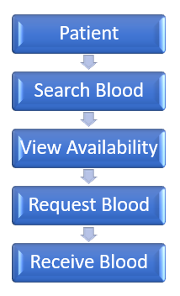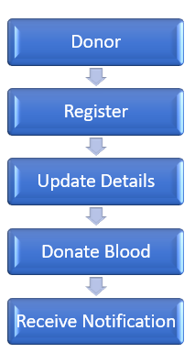

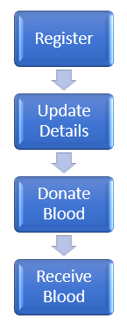
BLOOD DATA
PATIENT
DONOR

DATA FLOW DIAGRAM
ZERO LEVEL DFD

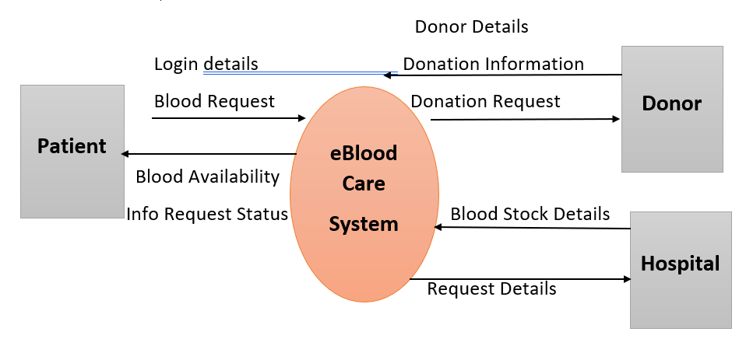

1 LEVEL (DFD)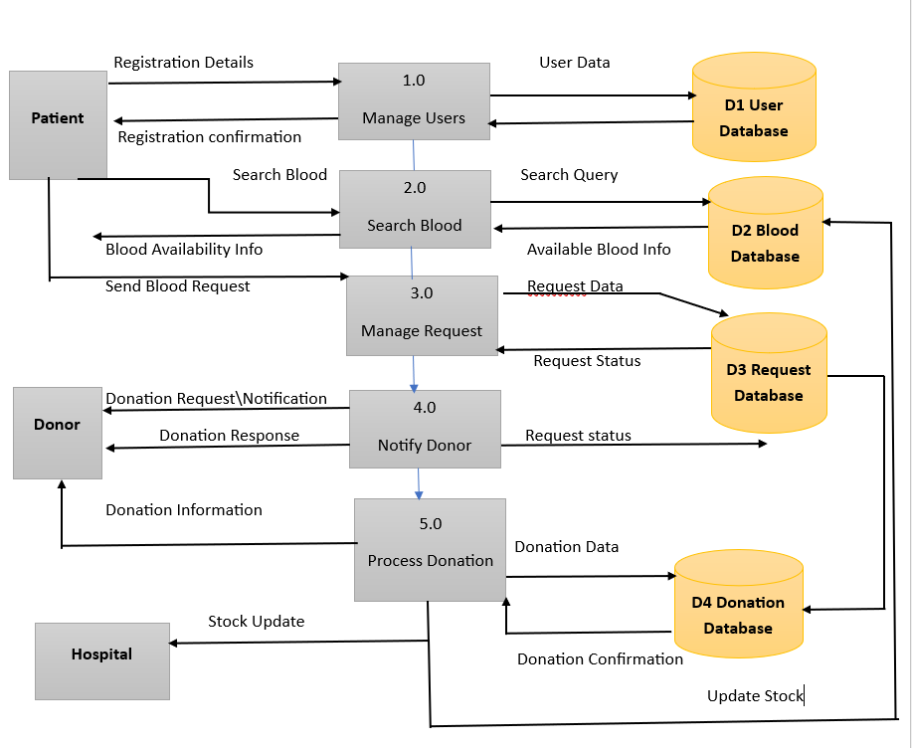

PERRT CHART

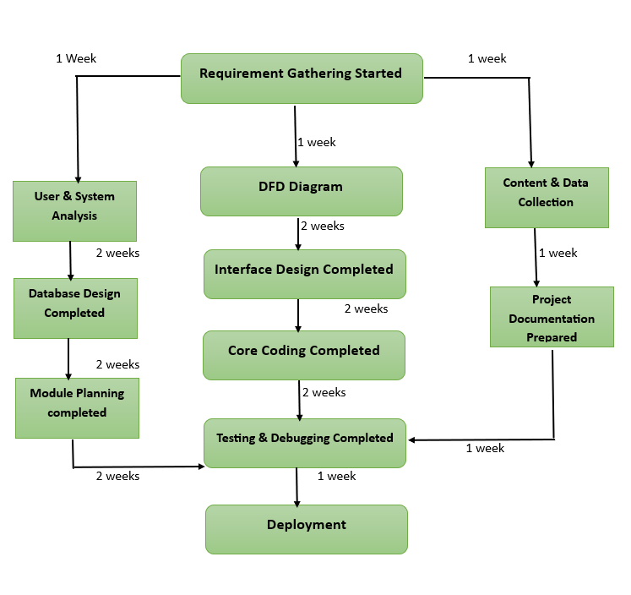

GANTT CHART

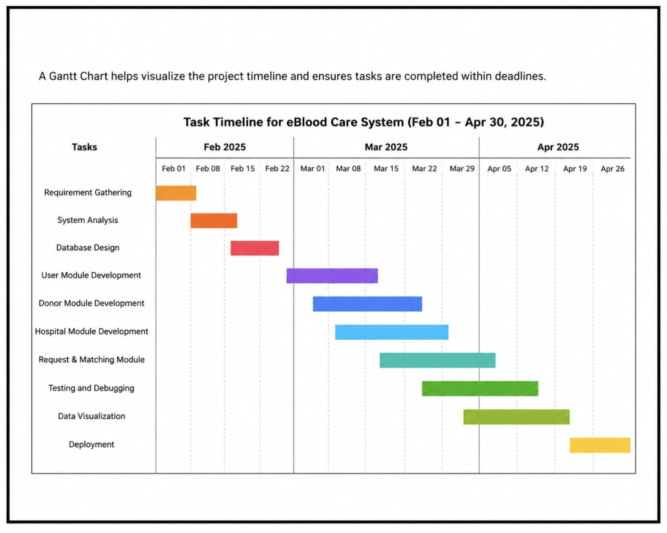

CODE

#include <stdio.h>
#include <string.h>

struct Donor {
char name[50];
char bloodGroup[5];
char phone[15];
};

struct Donor donor[10];
int donorCount = 0;

void registerDonor() {
printf("\n--- Donor Registration ---\n");
printf("Enter Donor Name: ");
scanf("%s", donor[donorCount].name);

printf("Enter Blood Group: ");
scanf("%s", donor[donorCount].bloodGroup);

printf("Enter Phone Number: ");
scanf("%s", donor[donorCount].phone);

donorCount++;

printf("Donor Registered Successfully!\n");
}

void searchBlood() {
char required[5];
int found = 0;

printf("\nEnter Required Blood Group: ");
scanf("%s", required);

printf("\nAvailable Donors:\n");

for (int i = 0; i < donorCount; i++) {
if (strcmp(required, donor[i].bloodGroup) == 0) {
printf("Name : %s\n", donor[i].name);
printf("Phone : %s\n", donor[i].phone);
printf("-----------------\n");
found = 1;
}
}

if (!found) {
printf("No donor available for %s\n", required);
}
}

void requestBlood() {
char patientName[50];
char bloodGroup[5];

printf("\n--- Blood Request ---\n");
printf("Enter Patient Name: ");
scanf("%s", patientName);

printf("Enter Required Blood Group: ");
scanf("%s", bloodGroup);

printf("Blood request submitted successfully!\n");
}

void displayDonors() {
printf("\n--- Donor List ---\n");

for (int i = 0; i < donorCount; i++) {
printf("Name : %s\n", donor[i].name);
printf("Blood Group : %s\n", donor[i].bloodGroup);
printf("Phone : %s\n", donor[i].phone);
printf("-----------------\n");
}
}

int main() {
int choice;

do {
printf("\n===== eBlood Care System =====\n");
printf("1. Register Donor\n");
printf("2. Search Blood\n");
printf("3. Request Blood\n");
printf("4. Display Donors\n");
printf("5. Exit\n");
printf("Enter choice: ");
scanf("%d", &choice);

switch(choice) {
case 1:
registerDonor();
break;

case 2:
searchBlood();
break;

case 3:
requestBlood();
break;

case 4:
displayDonors();
break;

case 5:
printf("Exiting...\n");
break;

default:
printf("Invalid choice!\n");
}

} while(choice != 5);

return 0;
}

TESTING

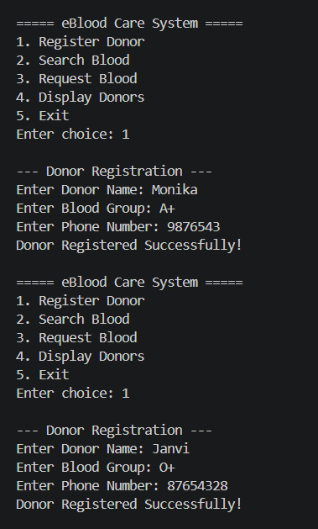
- Testing Overview
Testing was performed to ensure that all modules of the eBlood Care System work correctly and efficiently.
- Testing Techniques Used
Black Box Testing
- Tested donor registration
- Tested blood search
- Tested blood request
- Tested display donor list
- Tested exit functionality
White Box Testing
- Verified menu-driven structure
- Checked function calls and data flow
- Validated input and output conditions
Unit Testing
Modules tested individually
- Donor Registration Module
- Search Blood Module
- Request Blood Module
- Display Donors Module
System Testing
Complete system workflow was tested successfully from start to exit.

BIBLIOGRAPHY
DKMS India
Website- https://www.dkms-india.org/get-involved/programs/companies-can-save-lives
A non-profit organization that works to find blood stem cell donors and help patients suffering from blood cancer and blood disorders. (Accessed on 4 Feb 2026)
BloodConnect
Website- https://bloodconnect.org/
An Indian NGO that connects blood donors with patients and organizes blood donation camps across different cities. (Accessed on 7 Feb 2026)
Bagmo
Website- https://www.bagmo.in/
A healthcare company that provides blood transportation boxes and medical storage solutions for safe blood handling. (Accessed on 8 Feb 2026)
MTEC SC
Website- https://mtec-sc.org/
A healthcare technology organization focused on developing medical and blood care related solutions and innovations. (Accessed on 10 Feb 2026)
Lindis Blood Care
Website- https://www.lindis-bloodcare.com/
A medical company that creates devices for blood collection and transfusion safety to improve patient care. (Accessed on 13 2026)
Indian Red Cross Society
Website- https://www.indianredcross.org/
The app helps people request blood online quickly and easily. It was developed to improve transparency in blood donation and help patients get blood on time. (Accessed on 15 2026)
Omda
Website- https://omda.com/solutions/lims/
Omda is an international healthcare technology company that develops laboratory and blood management systems for hospitals and blood centers. (Accessed on 17 2026)

